Rotation-Asymmetric Shapes

Definition
# Source: AI Source: Provided by: [Data Path: Persons Table -> ID Column: 1, Name_En Column: Motasem Essam] -> From: [ChatGPT] on [7/25/2026]
Rotation-Asymmetric Shapes are shapes that do not remain unchanged when rotated by one or more specified angles about a given center of rotation.
For a shape $S$, if a rotation by angle $θ$about a center $O$produces a different shape, then:
$$R_{O,θ}\left(S\right)≠S$$
The shape is therefore asymmetric with respect to that rotation.
Important: Rotation-asymmetric does not necessarily mean that the shape has no symmetry at all. A shape may lack rotational symmetry while still having reflection symmetry.
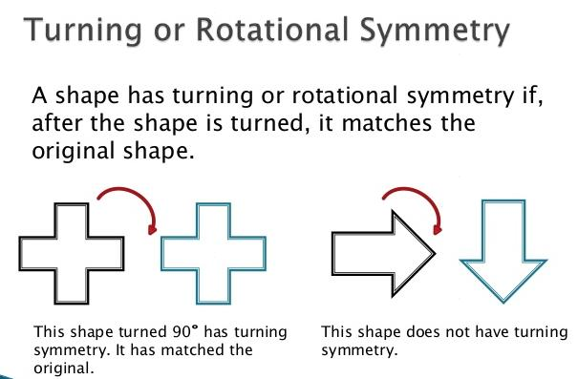
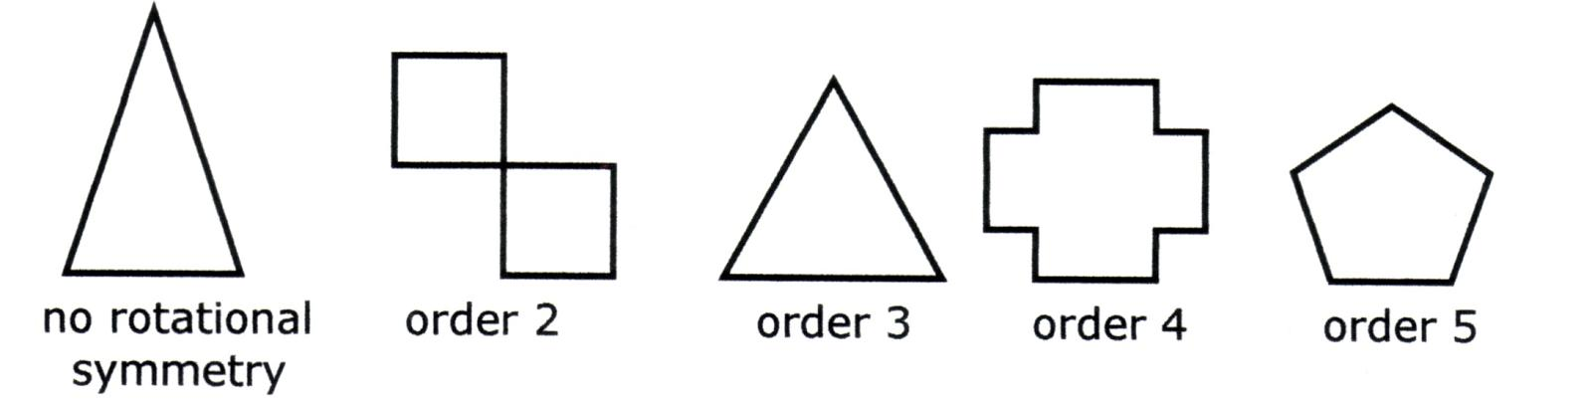
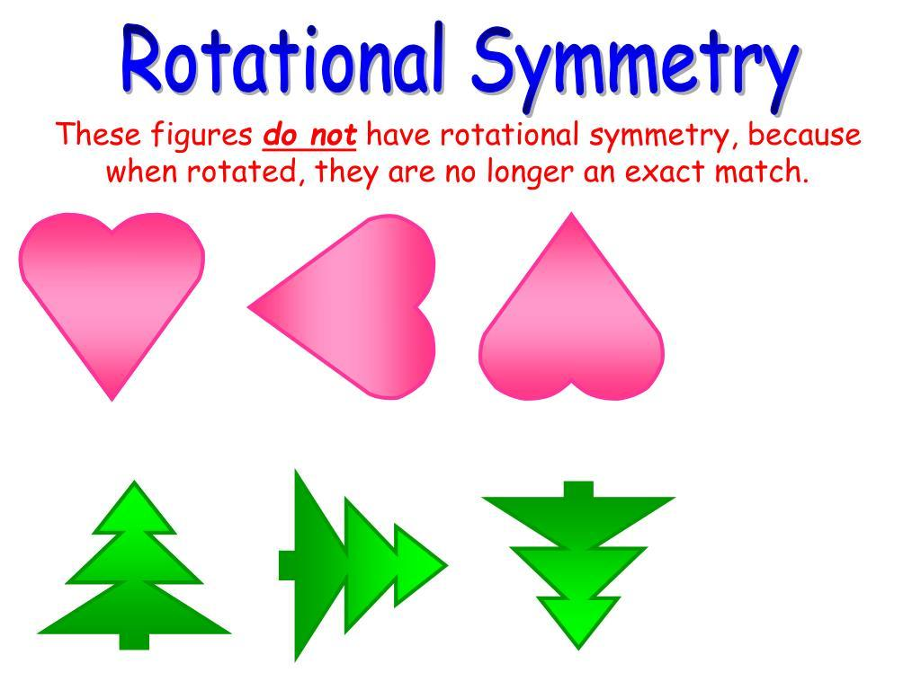

Fundamental Concept
# Source: AI Source: Provided by: [Data Path: Persons Table -> ID Column: 1, Name_En Column: Motasem Essam] -> From: [ChatGPT] on [7/25/2026]
Rotational symmetry occurs when a shape can be rotated through an angle less than ${360}^{∘}$and still coincide exactly with its original position.
If no such non-trivial rotation produces the same shape, the shape is rotation-asymmetric.
Example
Consider a scalene triangle:
- Rotate it by ${120}^{∘}$→ different orientation.
- Rotate it by ${240}^{∘}$→ different orientation.
- Rotate it by ${360}^{∘}$→ original position.
Therefore, the scalene triangle has no non-trivial rotational symmetry.

Rotation-Asymmetry Condition
# Source: AI Source: Provided by: [Data Path: Persons Table -> ID Column: 1, Name_En Column: Motasem Essam] -> From: [ChatGPT] on [7/25/2026]
Let:
- $S$= original shape
- $O$= center of rotation
- $θ$= rotation angle
Then:
$$\boxed{R_{O,θ}\left(S\right)≠S}$$
means the shape is different after the rotation.
For a shape to have no rotational symmetry, this must hold for every non-trivial rotation:
$$\boxed{R_{O,θ}\left(S\right)≠S \text{for} 0^{∘}<θ<{360}^{∘}}$$
The ${360}^{∘}$rotation is excluded because every shape returns to its original position after a full rotation.

Main Characteristics
# Source: AI Source: Provided by: [Data Path: Persons Table -> ID Column: 1, Name_En Column: Motasem Essam] -> From: [ChatGPT] on [7/25/2026]
Rotation-asymmetric shapes commonly have one or more of the following characteristics:
- Unequal corresponding features
- Unequal side lengths
- Unequal angles
- Uneven distribution of mass or area
- An irregular arrangement of components
- No repeating rotational pattern
- No non-trivial angle that maps the entire shape onto itself
However, irregularity is not required.
A shape can be geometrically regular in some respects while still lacking rotational symmetry.

Types of Rotation-Asymmetric Shapes
# Source: AI Source: Provided by: [Data Path: Persons Table -> ID Column: 1, Name_En Column: Motasem Essam] -> From: [ChatGPT] on [7/25/2026]
Rotation-asymmetric shapes can be classified according to their geometric structure.
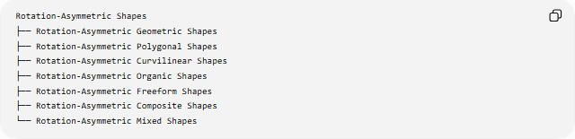
Rotation-Asymmetric Shapes
├── Rotation-Asymmetric Geometric Shapes
├── Rotation-Asymmetric Polygonal Shapes
├── Rotation-Asymmetric Curvilinear Shapes
├── Rotation-Asymmetric Organic Shapes
├── Rotation-Asymmetric Freeform Shapes
├── Rotation-Asymmetric Composite Shapes
└── Rotation-Asymmetric Mixed Shapes

Rotation-Asymmetric Geometric Shapes
# Source: AI Source: Provided by: [Data Path: Persons Table -> ID Column: 1, Name_En Column: Motasem Essam] -> From: [ChatGPT] on [7/25/2026]
These are geometric shapes that do not coincide with themselves under any non-trivial rotation.
Examples
- Scalene triangle
- Many irregular polygons
- Irregular quadrilaterals
- Uneven geometric arrangements
A scalene triangle is a common example.
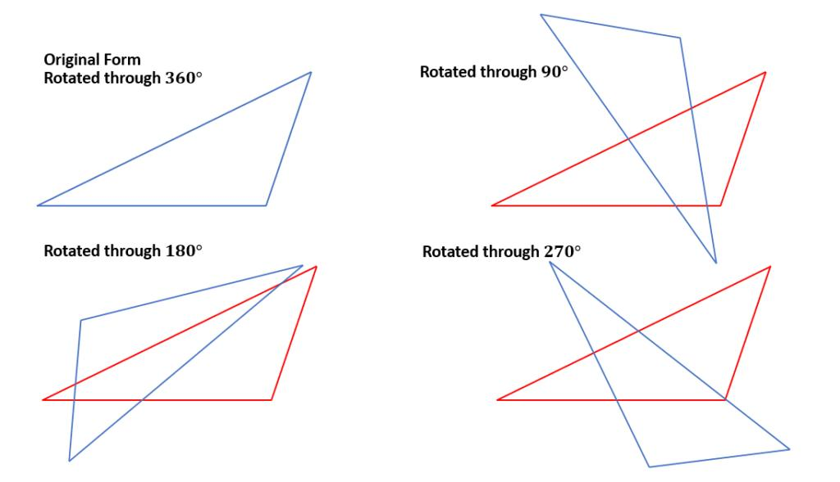
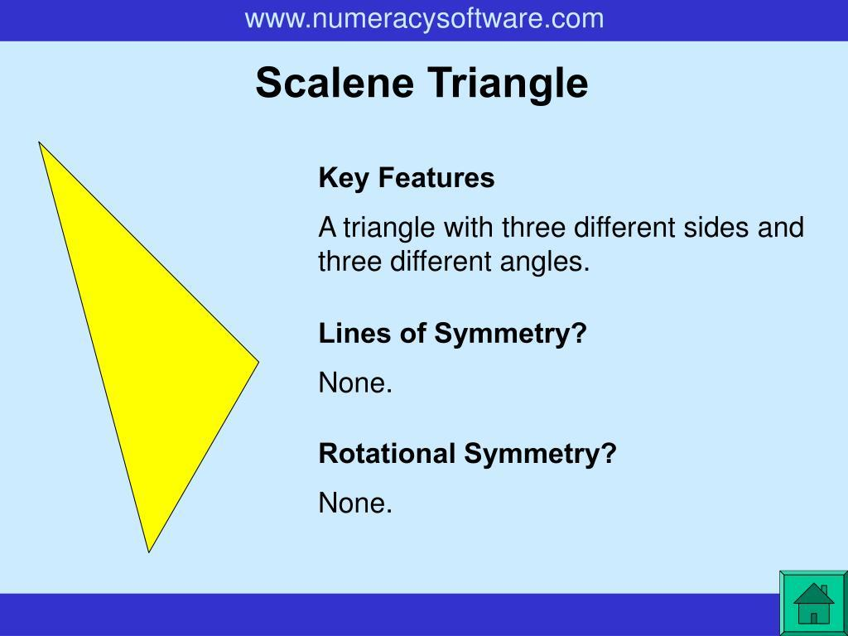
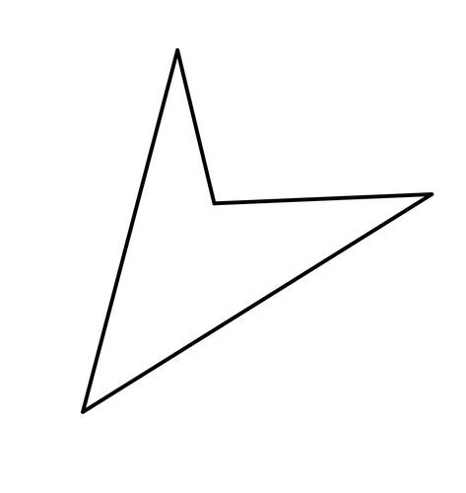

Rotation-Asymmetric Polygonal Shapes
# Source: AI Source: Provided by: [Data Path: Persons Table -> ID Column: 1, Name_En Column: Motasem Essam] -> From: [ChatGPT] on [7/25/2026]
These are polygonal shapes that do not have non-trivial rotational symmetry.
Examples
- Scalene triangles
- Irregular quadrilaterals
- Irregular pentagons
- Irregular hexagons
- Uneven concave polygons
For example, an irregular pentagon may have five unequal sides arranged in a way that prevents any rotation from reproducing the original shape.
Important distinction
A polygon having an odd or even number of sides does not by itself determine whether it is rotation-asymmetric.
The actual arrangement of its vertices determines its rotational symmetry.

Rotation-Asymmetric Curvilinear Shapes
# Source: AI Source: Provided by: [Data Path: Persons Table -> ID Column: 1, Name_En Column: Motasem Essam] -> From: [ChatGPT] on [7/25/2026]
These are shapes with curved boundaries that do not reproduce themselves under non-trivial rotation.
Examples include:
- Irregular curved regions
- Uneven curved outlines
- Asymmetric freeform curves
- Irregular combinations of arcs
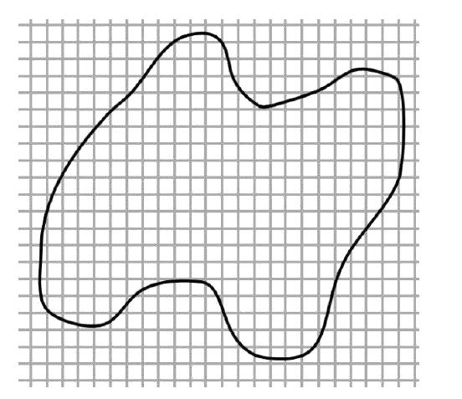
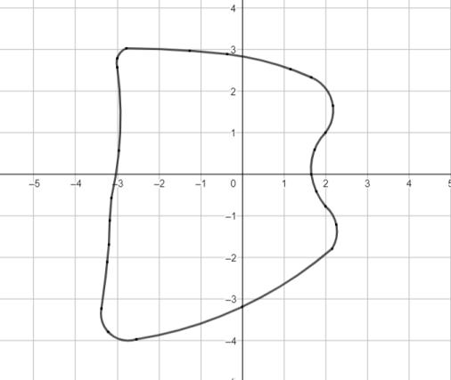
A shape can have smooth curves while still being rotation-asymmetric.

Rotation-Asymmetric Organic Shapes
# Source: AI Source: Provided by: [Data Path: Persons Table -> ID Column: 1, Name_En Column: Motasem Essam] -> From: [ChatGPT] on [7/25/2026]
Organic shapes frequently lack rotational symmetry because natural forms often contain uneven or non-repeating features.
Examples include:
- Leaf-like irregular forms
- Rock-like shapes
- Natural blobs
- Irregular biological forms
- Uneven natural outlines
Organic appearance and rotational asymmetry are separate concepts.
A natural object can sometimes have rotational symmetry, while another natural object may not.

Rotation-Asymmetric Freeform Shapes
# Source: AI Source: Provided by: [Data Path: Persons Table -> ID Column: 1, Name_En Column: Motasem Essam] -> From: [ChatGPT] on [7/25/2026]
A freeform shape may be rotation-asymmetric when its boundary has no repeating rotational pattern.
Examples:
- Abstract freeform shapes
- Freeform curved shapes
- Freeform mixed shapes
- Decorative freeform shapes
A freeform shape does not automatically have rotational asymmetry. The two properties describe different aspects:
$$\text{Freeform}≠\text{Rotation-Asymmetric}$$

Rotation-Asymmetric Composite Shapes
# Source: AI Source: Provided by: [Data Path: Persons Table -> ID Column: 1, Name_En Column: Motasem Essam] -> From: [ChatGPT] on [7/25/2026]
A composite shape consists of multiple components.
It becomes rotation-asymmetric when the arrangement of its components does not reproduce itself under non-trivial rotation.
For example:
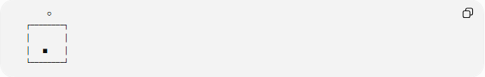
○
┌────────┐
│ │
│ ■ │
└────────┘
If the small component is positioned differently from the other features, rotating the entire arrangement may produce a different configuration.
Important point
Even if individual components are rotationally symmetric, the overall composite arrangement can be rotation-asymmetric.

Rotation-Asymmetric Mixed Shapes
# Source: AI Source: Provided by: [Data Path: Persons Table -> ID Column: 1, Name_En Column: Motasem Essam] -> From: [ChatGPT] on [7/25/2026]
These combine different types of geometric elements, such as:
- Straight lines
- Circular arcs
- Elliptical curves
- Freeform curves
- Different geometric regions
If their overall arrangement does not repeat under rotation, the result is rotation-asymmetric.
For example:
Circle + irregular polygon + curved boundary
may form a rotation-asymmetric mixed shape.

Rotation-Asymmetric Shapes with Reflection Symmetry
# Source: AI Source: Provided by: [Data Path: Persons Table -> ID Column: 1, Name_En Column: Motasem Essam] -> From: [ChatGPT] on [7/25/2026]
A shape can be rotation-asymmetric while still having reflection symmetry.
For example, an isosceles triangle has reflection symmetry but no non-trivial rotational symmetry.
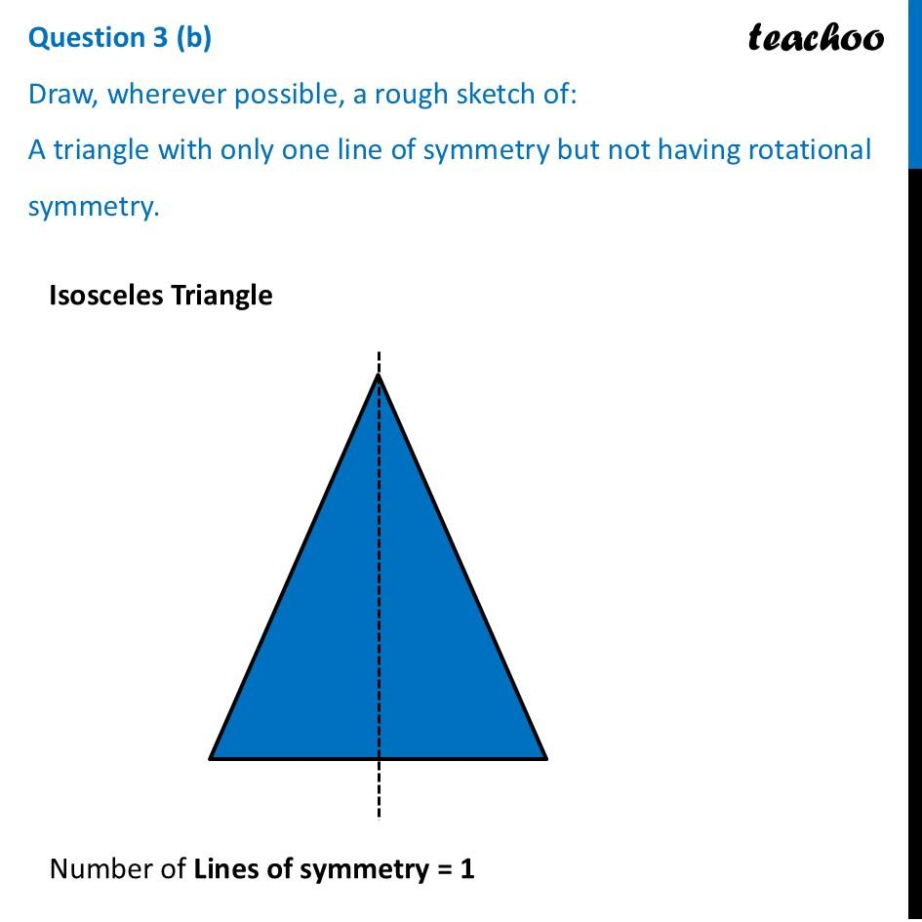
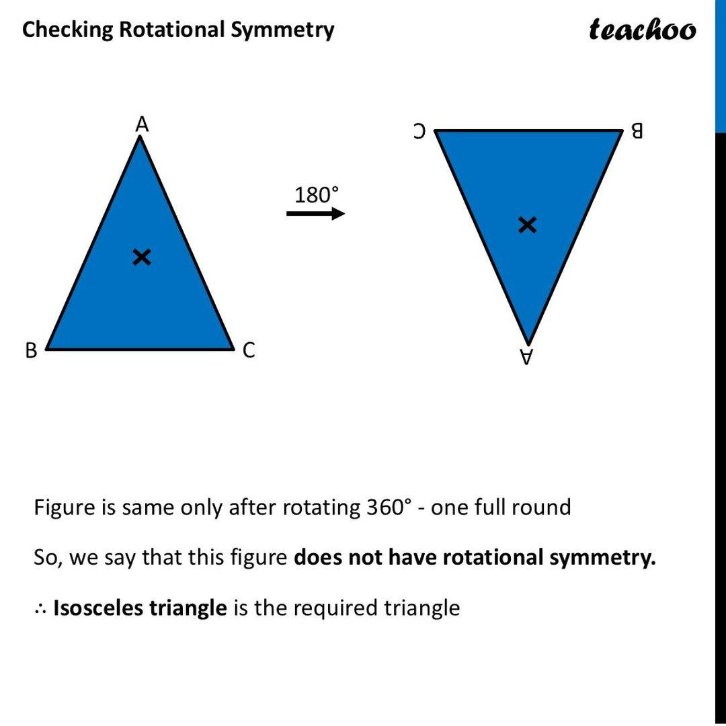
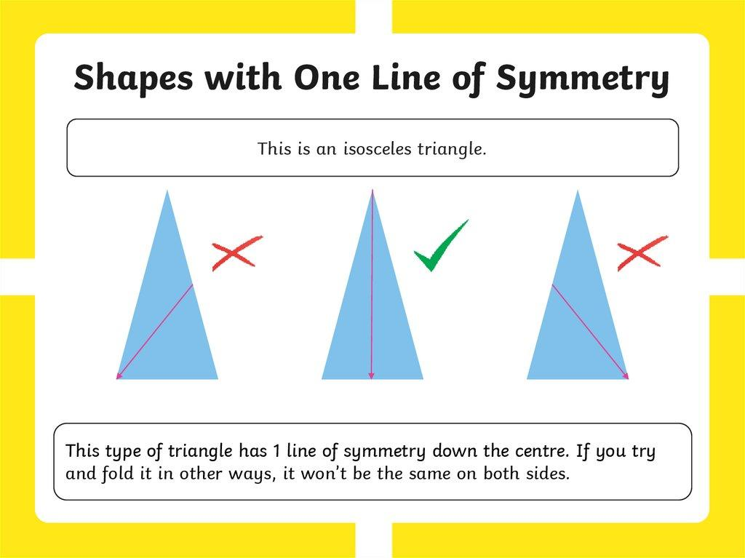
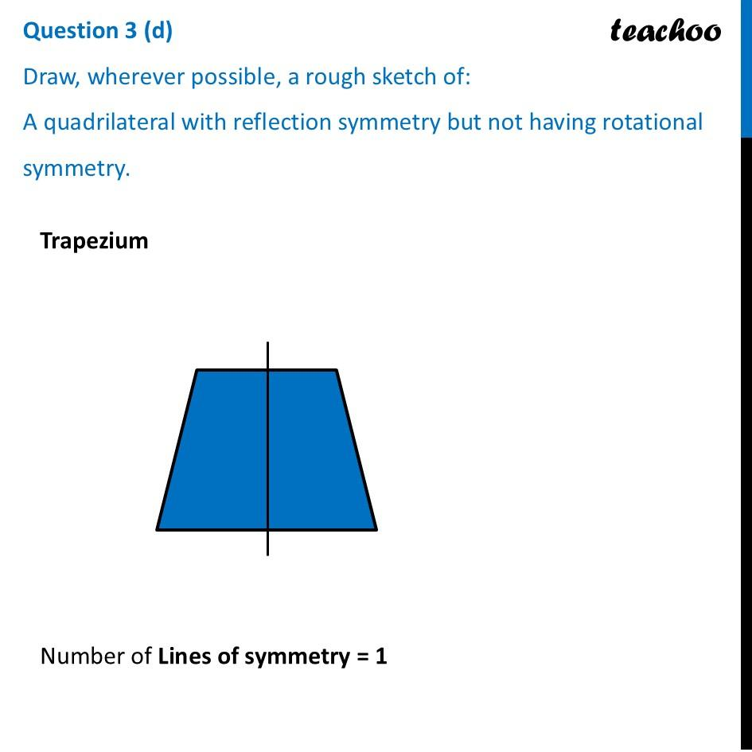
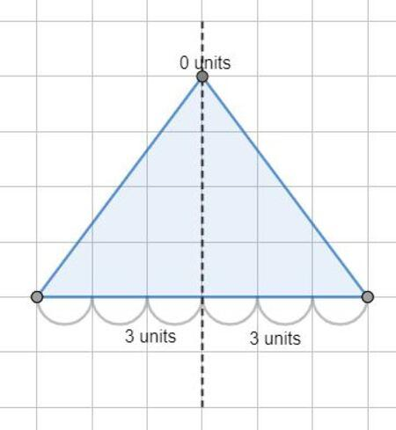
Therefore:
$$\boxed{\text{No rotational symmetry}⇏\text{No symmetry at all}}$$
This is an important distinction.

Rotation-Asymmetric vs Reflection-Asymmetric
# Source: AI Source: Provided by: [Data Path: Persons Table -> ID Column: 1, Name_En Column: Motasem Essam] -> From: [ChatGPT] on [7/25/2026]
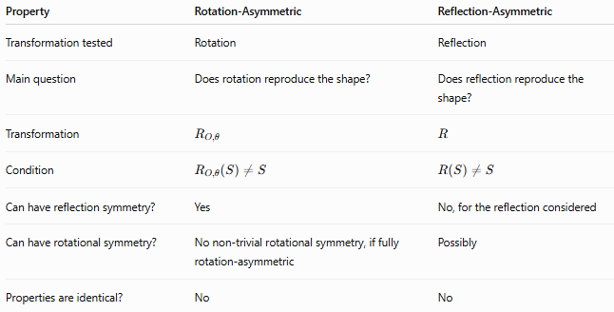
Property | Rotation-Asymmetric | Reflection-Asymmetric
Transformation tested | Rotation | Reflection
Main question | Does rotation reproduce the shape? | Does reflection reproduce the shape?
Transformation | $$R_{O,θ}$$ | $$R$$
Condition | $$R_{O,θ}\left(S\right)≠S$$ | $$R\left(S\right)≠S$$
Can have reflection symmetry? | Yes | No, for the reflection considered
Can have rotational symmetry? | No non-trivial rotational symmetry, if fully rotation-asymmetric | Possibly
Properties are identical? | No | No
A shape can therefore be:
- Rotation-asymmetric but reflection-symmetric
- Reflection-asymmetric but rotationally symmetric
- Both rotation-asymmetric and reflection-asymmetric
- Symmetric under both transformations

Rotation-Asymmetry vs Irregularity
# Source: AI Source: Provided by: [Data Path: Persons Table -> ID Column: 1, Name_En Column: Motasem Essam] -> From: [ChatGPT] on [7/25/2026]
These concepts should not be confused.
Irregular Shape
A shape that does not satisfy the conditions of a regular geometric shape.
Rotation-Asymmetric Shape
A shape that does not reproduce itself under non-trivial rotation.
Therefore:
$$\boxed{\text{Irregularity}≠\text{Rotation-Asymmetry}}$$
For example, a rectangle that is not a square is irregular as a quadrilateral but has rotational symmetry of order $2$.
Conversely, a shape can have carefully controlled dimensions yet lack rotational symmetry.

Order of Rotational Symmetry
# Source: AI Source: Provided by: [Data Path: Persons Table -> ID Column: 1, Name_En Column: Motasem Essam] -> From: [ChatGPT] on [7/25/2026]
The order of rotational symmetry is the number of times a shape coincides with itself during a complete ${360}^{∘}$rotation.
For a shape with rotational symmetry of order $n$:
$$θ=\frac{{360}^{∘}}{n}$$
Examples
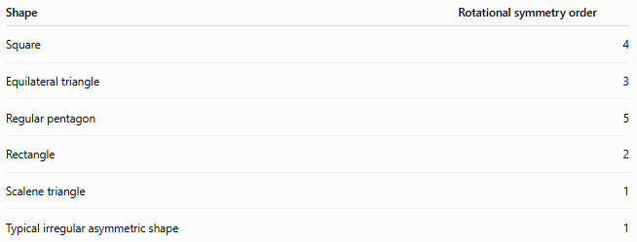
Shape | Rotational symmetry order
Square | 4
Equilateral triangle | 3
Regular pentagon | 5
Rectangle | 2
Scalene triangle | 1
Typical irregular asymmetric shape | 1
An order of 1 means the shape only matches itself after the complete ${360}^{∘}$rotation.
Thus, a shape with no non-trivial rotational symmetry can be described as having:
$$\boxed{\text{Rotational symmetry order }=1}$$

Rotation Angle
# Source: AI Source: Provided by: [Data Path: Persons Table -> ID Column: 1, Name_En Column: Motasem Essam] -> From: [ChatGPT] on [7/25/2026]
For a shape with rotational symmetry of order $n$, the smallest positive angle that reproduces the shape is:
$$\boxed{θ=\frac{{360}^{∘}}{n}}$$
For example, a square has:
$$n=4$$
so:
$$θ=\frac{{360}^{∘}}{4}={90}^{∘}$$
A rotation-asymmetric shape with order $1$has no smaller positive angle that reproduces it.

Mathematical Representation
# Source: AI Source: Provided by: [Data Path: Persons Table -> ID Column: 1, Name_En Column: Motasem Essam] -> From: [ChatGPT] on [7/25/2026]
A rotation about the origin by angle $θ$transforms a point $\left(x , y\right)$into:
$$\boxed{\begin{aligned}x^{'}&=x\cos{θ}-y\sin{θ} \\ y^{'}&=x\sin{θ}+y\cos{θ}\end{aligned}}$$
For rotation about a point $\left(h , k\right)$, translate the point to the origin, rotate it, and translate it back.
The transformation is:
$$\boxed{\begin{aligned}x^{'}&=h+\left(x-h\right)\cos{θ}-\left(y-k\right)\sin{θ} \\ y^{'}&=k+\left(x-h\right)\sin{θ}+\left(y-k\right)\cos{θ}\end{aligned}}$$
A shape is rotation-asymmetric for a particular angle when the transformed shape differs from the original.

Rotation-Asymmetric Curves
# Source: AI Source: Provided by: [Data Path: Persons Table -> ID Column: 1, Name_En Column: Motasem Essam] -> From: [ChatGPT] on [7/25/2026]
For a curve represented parametrically by
$$r\left(t\right)=\left(\begin{matrix}x\left(t\right) \\ y\left(t\right)\end{matrix}\right),$$
rotation about the origin gives:
$$r_{θ}\left(t\right)=\left(\begin{matrix}\cos{θ} & -\sin{θ} \\ \sin{θ} & \cos{θ}\end{matrix}\right)r\left(t\right)$$
If:
$$r_{θ}\left(t\right)≠r\left(t\right)$$
for the relevant transformation, the curve is rotation-asymmetric with respect to that rotation.

Examples

Example 1 — Scalene Triangle
# Source: AI Source: Provided by: [Data Path: Persons Table -> ID Column: 1, Name_En Column: Motasem Essam] -> From: [ChatGPT] on [7/25/2026]
A scalene triangle has three unequal sides.
It does not coincide with itself after a ${120}^{∘}$or ${240}^{∘}$rotation.
Therefore:
$$\boxed{\text{Scalene triangle }\text{→} \text{rotation-asymmetric}}$$

Example 2 — Rectangle
# Source: AI Source: Provided by: [Data Path: Persons Table -> ID Column: 1, Name_En Column: Motasem Essam] -> From: [ChatGPT] on [7/25/2026]
A non-square rectangle has rotational symmetry of order $2$.
A ${180}^{∘}$rotation reproduces it.
Therefore:
$$\boxed{\text{Rectangle }\text{→} \text{not} \text{rotation-asymmetric}}$$

Example 3 — Irregular Pentagon
# Source: AI Source: Provided by: [Data Path: Persons Table -> ID Column: 1, Name_En Column: Motasem Essam] -> From: [ChatGPT] on [7/25/2026]
An irregular pentagon with no repeating vertex arrangement generally has no non-trivial rotational symmetry.
Therefore:
$$\boxed{\text{Irregular pentagon }\text{→} \text{rotation-asymmetric}}$$

Example 4 — Isosceles Triangle
# Source: AI Source: Provided by: [Data Path: Persons Table -> ID Column: 1, Name_En Column: Motasem Essam] -> From: [ChatGPT] on [7/25/2026]
An isosceles triangle has reflection symmetry but no non-trivial rotational symmetry.
Therefore:
$$\boxed{\text{Isosceles triangle }\text{→} \text{rotation-asymmetric}}$$
with respect to rotational symmetry.

Classification Summary
# Source: AI Source: Provided by: [Data Path: Persons Table -> ID Column: 1, Name_En Column: Motasem Essam] -> From: [ChatGPT] on [7/25/2026]
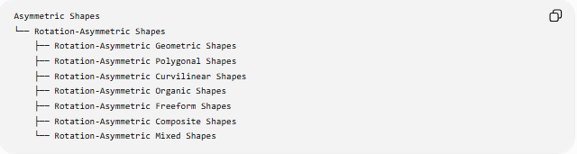
Asymmetric Shapes
└── Rotation-Asymmetric Shapes
├── Rotation-Asymmetric Geometric Shapes
├── Rotation-Asymmetric Polygonal Shapes
├── Rotation-Asymmetric Curvilinear Shapes
├── Rotation-Asymmetric Organic Shapes
├── Rotation-Asymmetric Freeform Shapes
├── Rotation-Asymmetric Composite Shapes
└── Rotation-Asymmetric Mixed Shapes
A more transformation-focused classification is:
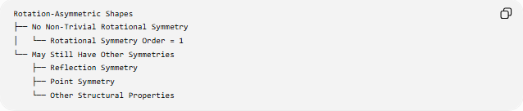
Rotation-Asymmetric Shapes
├── No Non-Trivial Rotational Symmetry
│ └── Rotational Symmetry Order = 1
└── May Still Have Other Symmetries
├── Reflection Symmetry
├── Point Symmetry
└── Other Structural Properties

Key Distinctions
# Source: AI Source: Provided by: [Data Path: Persons Table -> ID Column: 1, Name_En Column: Motasem Essam] -> From: [ChatGPT] on [7/25/2026]
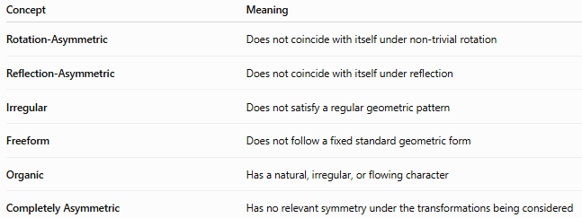
Concept | Meaning
Rotation-Asymmetric | Does not coincide with itself under non-trivial rotation
Reflection-Asymmetric | Does not coincide with itself under reflection
Irregular | Does not satisfy a regular geometric pattern
Freeform | Does not follow a fixed standard geometric form
Organic | Has a natural, irregular, or flowing character
Completely Asymmetric | Has no relevant symmetry under the transformations being considered
The most important distinction is:
$$\boxed{\text{Rotation-asymmetric}≠\text{completely asymmetric}}$$

Key Points
# Source: AI Source: Provided by: [Data Path: Persons Table -> ID Column: 1, Name_En Column: Motasem Essam] -> From: [ChatGPT] on [7/25/2026]
- A rotation-asymmetric shape does not reproduce itself under a non-trivial rotation.
- Its rotational symmetry order is typically 1.
- A ${360}^{∘}$rotation always returns a shape to its original position and is therefore not considered evidence of rotational symmetry.
- Rotation-asymmetry is specifically about rotation, not reflection.
- A shape can be rotation-asymmetric while still having reflection symmetry.
- Rotation-asymmetry and irregularity are different properties.
- Rotation-asymmetric shapes can be polygonal, curvilinear, organic, freeform, composite, or mixed.
- The actual arrangement of a shape's features determines its rotational symmetry.
- A shape must be tested about a specified center and rotation angle when discussing a particular rotational transformation.

